**Wingrove Primary School**

**Term and Holiday dates for 2024 - 2025**

SEPTEMBER 2024

OCTOBER 2024

NOVEMBER 2024

M

T

W

T

F

S

S

1

8

M

7

T

1

8

W

2

9

T

3

F

4

S

5

S

6

M

**4**

T

W

T

F

1

8

S

2

9

S

3

10

**2**

9

**3**

4

5

6

7

10 11 12 13

5

6

7

10 11 12 13 14 15

14 15 16 17 18 19 20

21 22 23 24 25 26 27

28 29 30 31

11 12 13 14 15 16 17

18 19 20 21 22 23 24

25 26 27 28 29 30

1

2

3

6 17 18 19 20 21 22

3 24 25 26 27 28 29

0

DECEMBER 2024

JANUARY 2025

FEBRUARY 2025

M

T

W

T

F

S

S

1

8

M

6

T

7

W

1

8

T

2

9

F

3

S

4

S

5

M

3

T

W

T

F

S

1

8

S

2

9

2

9

3

4

5

6

7

10 11 12

4

5

6

7

10 11 12 13 14 15

13 14 15 16 17 18 19

20 21 22 23 24 25 26

27 28 29 30 31

10 11 12 13 14 15 16

17 18 19 20 21 22 23

24 25 26 27 28

16 17 18 19 20 21 22

23 24 25 26 27 28 29

30 31

MARCH 2025

APRIL 2025

MAY 2025

M

T

4

W

T

F

S

1

8

S

2

9

M

7

T

1

8

W

2

9

T

3

F

4

S

5

S

6

M

5

T

6

W

T

1

8

F

2

9

S

3

S

4

3

5

6

7

10 11 12 13

7

10 11

10 11 12 13 14 15 16

17 18 19 20 21 22 23

24 25 26 27 28 29 30

31

14 15 16 17 18 19 20

21 22 23 24 25 26 27

28 29 30

12 13 14 15 16 17 18

19 20 21 22 23 24 25

26 27 28 29 30 31

JUNE 2025

JULY 2025

AUGUST 2025

M

T

3

W

T

F

S

7

S

1

8

M

7

T

1

8

W

2

9

T

3

F

4

S

5

S

6

M

4

T

5

W

T

F

1

8

S

2

9

S

3

10

2

**9**

4

5

6

10 11 12 13

6

7

10 11 12 13 14 15

14 15 16 17 18 19 20

21 22 23 24 25 26 27

28 29 30 31

11 12 13 14 15 16 17

18 19 20 21 22 23 24

25 26 27 28 29 30 31

1

2

3

6 17 18 19 20 21 22

3 24 25 26 27 28 29

0

Autumn

Term

Spring

Term

Summer

Term

Bank

Holiday

School

Holiday

1. Foundation Trust, Academy and Voluntary Aided (church) schools are not obliged to follow these dates

and may choose to set a different calendar. You should contact individual schools for confirmation.

2. Maintained schools are usually open for the teaching of pupils for 190 days in a school year. This

calendar shows 194 term time days. The additional 4 days will be used by schools for non-teaching days.

Schools are closed to pupils on these days. **Four days have been confirmed**, please see calendar dates in blue. The dates of the non-teaching days are not necessarily the same across all schools. Individual schools will notify parents of the dates when school is closed to pupils for non-teaching days.

**Schools re-open on MONDAY, 1st September 2025**

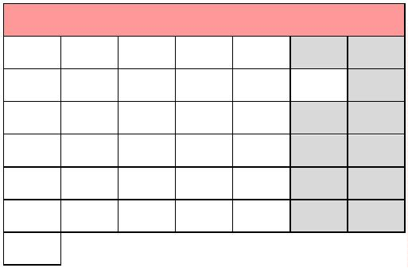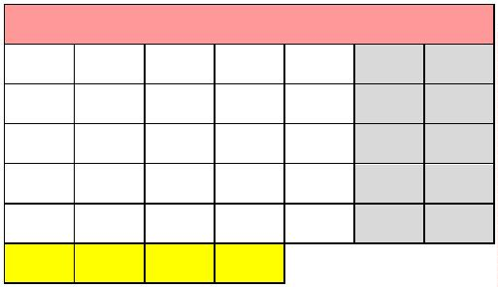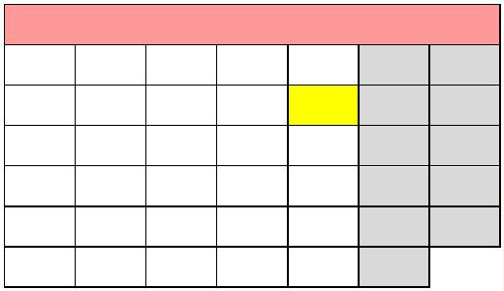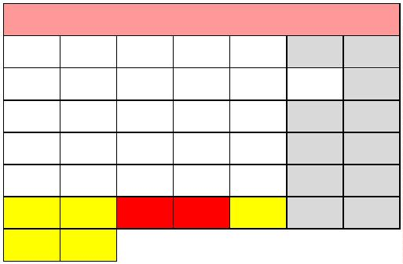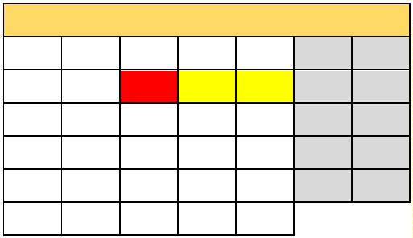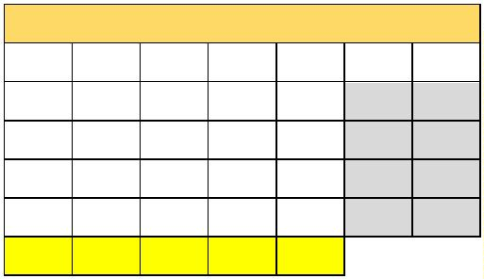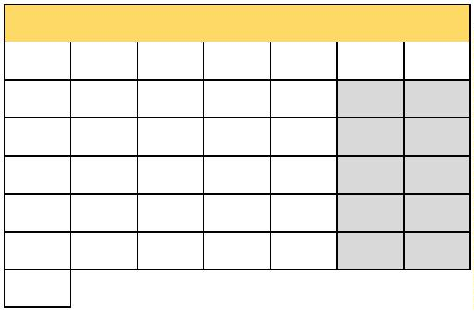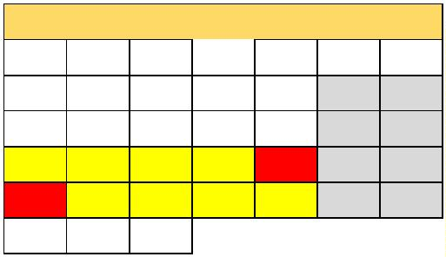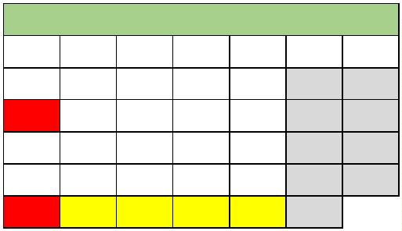ooxWord://word/media/image11.jpeg