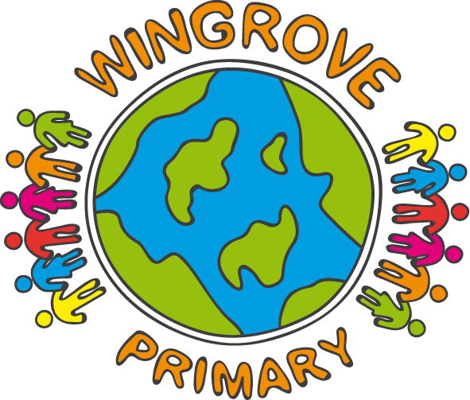
Below is a list of suggested texts for your child to read over the summer and during the next year in school. It is intended to be used as a guide and, as most of these texts will be available in the local or city library, there should not be any need to purchase every one.

Year 4
You’re a Bad Man Mr Gum, by Andy Stanton
Dragon’s Dale, By Slamandra Drake
Nicole the Beach Fairy, by Daisy Meadows
The Butterfly Lion, by Michael Morpurgo
The Diary of a Wimpy Kid, by Jeff Kinney (series of 4)
Green Eggs and Ham, by Dr Seuss
Problems with a Python, by Jeremy Strong
Percy Jackson and the Last Olympian, by Rick Riordan
Horrid Henry and the Secret Club, by Francesca Simon
Famous Five - Case of the Messy Mucked Up Masterpiece, by Enid Blyton
Cesc Fabregas World Cup Heroes, by Tom Oldfield
Esio Trot, by Roald Dahl
Ally’s World, by Karen Mcombie
Famous Five go to Kirin Island, by Enid Blyton
Girls in Love, by Jacqueline Wilson
Complete Puzzle World, by Susannah Leigh
Humphrey, by Betty G Birney
Deeper than Blue, by Jill Hucklesby
Captain Underpants, by Dav Pilkey
We Animals Would Like a Word With You (Poems), by John Agard
A Caribbean Dozen (with Grace Nicholls), by John Agard
The Better Brown Stories, by Allan Ahlberg
Woof!, by Allan Ahlberg
Heard it in the Playground (Poems), by Allan Ahlberg
Please Mrs Butler (Poems), by Allan Ahlberg
It was a Dark and Stormy Night, by Allan Ahlberg
The Clothes Horse, by Allan Ahlberg
A Handful of Gold, by Joan Aitken
The Winter Sleepwalker, by Joan Aitken
Fog Hounds Wind cat Sea Mice, by Joan Aitken
Pig Heart Boy, by Malorie Blackman
Football Fever Ed, by Tony Bradman
Alice’s Adventures in Wonderland, by Lewis Carroll
Millions, by Frank Cottrell Boyce
Lizzie Dripping, by Helen Cresswell
The Piemakers, by Helen Cresswell
The Sea Piper, by Helen Cresswell
James and the Giant Peach, by Roald Dahl
Matilda, by Roald Dahl
Dirty Beasts, by Roald Dahl
Groosham Grange, by Anthony Horowitz
Robi Dobi, by Madhur Jaffrey
The Time-Travelling Cat, by Julia Jarman
Chewing the Cud, by Dick King-Smith
The Crowstarver, by Dick King-Smith
The Hodgeheg, by Dick King-Smith
Dodo are Forever, by Dick King-Smith
Dragon Boy, by Dick King-Smith
Saddlebottom, by Dick King-Smith
The Invisible Dog, by Dick King-Smith
The Merrythought, by Dick King-Smith
The Swoose, by Dick King-Smith
The Sheep- Pig, by Dick King-Smith
The Toby Man, by Dick King-Smith
Any Title by The Brothers Grimm

